
(e) david.bloom@storyhousepr.co.uk (t) 07980 297 299
(e) lewis.jenkins@storyhousepr.co.uk (t) 07824 538 900
www.storyhousepr.co.uk

IMAGES HERE
SOCIAL ASSETS HERE
www.hadestown.co.uk
CAST ANNOUNCED FOR THE WEST END PRODUCTION OF TONY® AND GRAMMY® AWARD-WINNING, HADESTOWN
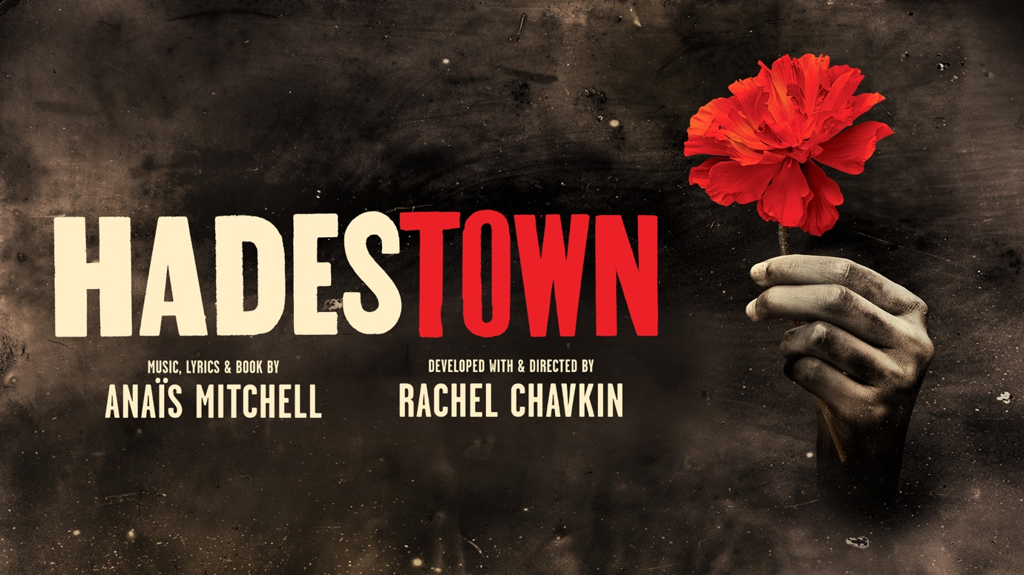
LYRIC THEATRE, LONDON FROM 10 FEBRUARY 2024
uk.hadestown.com
London; Thursday 16 November 2023: Casting has been confirmed for the highly anticipated West End premiere of multi award-winning Hadestown which will open at the Lyric Theatre, London with performances from Saturday 10 February 2024.
Winner of 8 Tony® Awards including ‘Best Musical’ and a Grammy® Award for ‘Best Musical Theatre Album’, Hadestown returns to London five years after its sold-out run at the National Theatre in 2018.
Blending modern American folk music with New Orleans-inspired jazz, the Original Broadway Cast Recording of Hadestown is one of the most streamed cast albums of all time with over 340 million streams to date. It won the Grammy Award® for ‘Best Musical Theatre Album’, topped Billboard’s Broadway Cast Recording chart and debuted at #8 on the Top Album chart.
The West End cast will include Dónal Finn (Orpheus) known for playing Mat Cauthon in Series 2 of Prime’s The Wheel of Time, Grace Hodgett Young (Eurydice) who is currently starring as Betty Schaefer in Sunset Boulevard at the Savoy Theatre, Grammy® Award-winner Zachary James (Hades) who originated the role of Lurch in The Addams Family at the Lunt-Fontanne Theatre on Broadway and the role of Abraham Lincoln in the world premiere of Philip Glass Opera The Perfect American at Teatro Real in Madrid, Musical Theatre actress and singer Melanie La Barrie (Hermes) whose many credits include originating the roles of Mrs. Corry in Mary Poppins at the Prince Edward Theatre and Nurse in & Juliet at the Shaftesbury Theatre, and Gloria Onitiri (Persephone) who originated the role of Fairy Godmother in Andrew Lloyd Webber’s Cinderella at the Gillian Lynne Theatre, Princess Desiree in Upstart Crow at the Apollo Theatre and who previously performed in Hadestown at the National Theatre.
Bella Brown, Madeline Charlemagne, and Allie Daniel will play the Fates and Lauren Azania, Tiago Dhondt Bamberger, Beth Hinton-Lever, Waylon Jacobs, and Christopher Short will play the Workers, with Lucinda Buckley, Ryesha Higgs, Miriam Nyarko, and Simon Oskarsson as Swings.
Hadestown features music, lyrics, and book by acclaimed Grammy®-winning singer-songwriter and BBC Radio 2 Folk Award-winner Anaïs Mitchell, who originated Hadestown as an indie theatre project and acclaimed album. Mitchell then transformed the show into a genre-defying new musical alongside artistic collaborator and Tony® Award-winning director Rachel Chavkin, whose theatre credits include Mission Drift (National Theatre) and American Clock (The Old Vic).

Hadestown takes you on an unforgettable journey to the underworld and back, intertwining two mythic love stories – that of young dreamers Orpheus and Eurydice, and that of King Hades and his wife Persephone. A deeply resonant and defiantly hopeful theatrical experience, Hadestown invites you to imagine how the world could be.

The Hadestown creative team features Obie Award® winner and Chita Rivera Award® winner David Neumann (choreography), Tony Award® winner Rachel Hauck (scenic design), four-time Tony® Award nominee Michael Krass (costume design), two-time Tony Award® winner Bradley King (lighting design), Tony® Award winners Nevin Steinberg and Jessica Paz (sound design), Liam Robinson (music supervision and vocal arrangements), Tony® Award winners Michael Chorney and Todd Sickafoose (arrangements and orchestrations), and Ken Cerniglia (dramaturgy). Casting for the London production is by Jacob Sparrow.

Hadestown is produced in London by Mara Isaacs, Dale Franzen, Hunter Arnold, Tom Kirdahy and the National Theatre in association with JAS Theatricals.

//Ends.

HADESTOWN LISTING INFORMATION

Website: uk.hadestown.com
Instagram: HadestownUK
Twitter: HadestownUK
Facebook: HadestownUK

Tickets: Tickets from £20

Box Office: Book via nimaxtheatres.com / call 0330 333 4812
(Phones line are open Monday –Saturday 10am – 6pm (excluding Bank Holidays)

For Groups book via groups@nimaxtheatres.com / call 0330 333 4817

Address: Lyric Theatre, 29 Shaftesbury Avenue, London, W1 7ES

Dates: from Saturday 10 February 2024

Press Night: Wednesday 21 February at 7pm

Performances Schedule:

Evening Performances: Tuesday – Saturday at 7.30pm
Matinee Performances: Thursday and Saturday at 2.30pm with a Sunday performance at 3pm

Assisted Performances:

Captioned Performance: Saturday 20 April 2024 at 2.30pm
Audio Described Performance: Saturday 27 April 2024 at 2.30pm
BSL Interpreted Performance: Saturday 4 May 2024 at 2.30pm
Captioned Performance: Wednesday 12 June 2024 at 7.30pm
Audio Described Performance: Wednesday 19 June 2024 at 7.30pm
BSL Interpreted Performance: Wednesday 26 June 2024 at 7.30pm

Running Time: Approx. 2 hours and 25 minutes including interval

NOTES TO EDITORS

HADESTOWN

Hadestown opened in 2016 at the New York Theatre Workshop before a production in Edmonton, Canada and a sold out run at the National Theatre in 2018. After further development, Hadestown premiered at Broadway’s Walter Kerr Theater, winning 8 Tony Awards including Best Musical. It now holds the record for the highest grossing musical and longest running show in the theatre’s 100-year history. The North American tour is celebrating its second year of sold-out performances with many return engagements also announced from July 2023.

Hadestown was developed with funding from the Eli and Edythe Broad Stage at the Santa Monica College Performing Arts Center and was further developed by The Ground Floor at Berkeley Repertory Theatre. Hadestown was co-conceived by Ben t. Matchstick.

Hadestown in the West End is supported by American Express, the National Theatre’s Preferred Card Partner.

